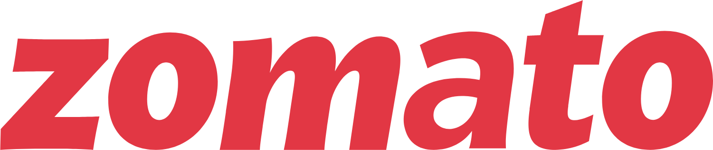

Product Dissection for Zomato

Company Overview:

Zomato, founded in 2008 by Deepinder Goyal and Pankaj Chaddah, has transformed the food industry by connecting customers, restaurant partners, and delivery partners. Starting as a restaurant discovery guide, it has evolved into a global food delivery giant. Zomato addresses the core needs of food enthusiasts: discovering great places to eat, reading reviews, and getting food delivered conveniently to their doorstep.

Product Dissection and Real-World Problems Solved by Zomato:

Zomato has effectively addressed the gap between hungry customers and restaurants through technology.

- Discovery & Trust: Before platforms like Zomato, knowing the quality, menu, or pricing of a restaurant required a physical visit or reliance on word-of-mouth. Zomato solved this by aggregating menus, photos, and user reviews in one place.
- Convenience of Logistics: The platform solved the "last-mile" delivery challenge, allowing users to enjoy restaurant-quality food without leaving their homes.
- Information Asymmetry: By providing ratings and average cost estimates, Zomato creates transparency, helping users make informed dining decisions.

Case Study: Real-World Problems and Zomato’s Innovative Solutions

Problem 1: The "What to Eat?" Discovery Dilemma
- Real-World Challenge: People often spend more time deciding where to eat than actually eating. With hundreds of local restaurants, customers suffer from "choice paralysis" and struggle to find places that match their specific mood, budget, or location without making multiple phone calls.
- Zomato’s Solution: Zomato solved this with a hyper-categorized discovery platform. By organizing restaurants into "Collections" (e.g., "Romantic Date Spots," "Late Night Cravings") and offering granular filters, they turned a confusing search process into a curated experience.

Problem 2: Uncertainty of Food Quality and Hygiene
- Real-World Challenge: Trying a new restaurant is risky. Customers have no way to verify the portion size, taste, or hygiene standards of a kitchen just by looking at a paper flyer or a restaurant name board.
- Zomato’s Solution: Zomato democratized food quality assurance through "Social Proof." By allowing users to upload photos of the actual food (vs. marketing photos) and write detailed reviews, they created a transparency layer. The "Zomato Verified" tag and hygiene ratings further reduce the anxiety of ordering from unknown places.

Problem 3: The "Last-Mile" Logistics & Waiting Game
- Real-World Challenge: Before food tech, delivery was unreliable and dependent on the restaurant's own limited staff. Customers had no idea if their food was being cooked or if the driver was lost, leading to frustration and cold food.
- Zomato’s Solution: Zomato introduced a dedicated fleet of delivery partners and live GPS tracking. This solved the logistics gap for restaurants that couldn't afford their own drivers and gave customers real-time visibility into their order status, from "Kitchen" to "Doorstep."

Problem 4: Complexity of Dietary Needs & Payment Friction
- Real-World Challenge: Customers with specific dietary preferences (e.g., Pure Veg, Jain, Vegan, Gluten-free) find it difficult to scan through massive physical menus to find what they can eat. Additionally, managing cash on delivery often led to change issues and friction at the doorstep.
- Zomato’s Solution: The app introduced "Smart Filters" that instantly hide incompatible dishes, making the menu personalized for the user. Simultaneously, they integrated seamless digital payment gateways (UPI, Wallets, Cards) and "Contactless Dining," removing the friction of cash handling entirely.

Conclusion :
In summary, Zomato did not just digitize menus; they fundamentally solved the friction points of the traditional dining experience. By identifying the key struggles of the ecosystem—uncertainty for customers, logistical hurdles for restaurants, and discovery issues for both—Zomato created a unified platform. Their solutions transformed a chaotic, offline industry into a streamlined, data-driven marketplace where information is transparent and food is accessible with a single tap.

Top Features of Zomato:

Smart Restaurant Discovery & Search
- This is the core engine of the app. Beyond simple text search, it utilizes location data to show the nearest best options. It includes curated lists ("Collections") and advanced sorting (by rating, delivery time, or cost) to help users make decisions in seconds rather than minutes.
Seamless Online Ordering & Customization
- The ordering flow is designed to mimic a real conversation with a waiter. Users can customize dishes (e.g., "make it spicy," "remove onions") directly in the app. It also remembers past orders, allowing for a "One-Tap Reorder" feature that saves time for regular customers.
Real-Time Live Order Tracking
- This feature builds trust by removing the "black box" of delivery. It uses GPS integration to show the delivery partner's exact movement on a map. It also provides dynamic timestamps (ETA) that adjust based on traffic and weather conditions, keeping the user informed at every step.
Community Reviews, Ratings & Photos
- Zomato separates ratings into "Delivery" and "Dining" to provide accurate expectations. The feature allows users to upload photos of the menu and the food, creating a user-generated repository of data that is often more reliable and up-to-date than what restaurants provide themselves.
Zomato Gold / Pro (Loyalty Program)
- A subscription-based feature designed to increase user retention. It offers tangible financial benefits, such as significant discounts on total bills or free delivery on all orders. This gamifies the experience and encourages users to order more frequently to "recover" their subscription cost.

Schema Design for Zomato:
Based on the features identified, here is the data structure (Schema) for the platform.

1. User Entity:
Represents the customers using the app.
- UserID (PK): Unique identifier for each user.
- Name: Full name of the user.
- Email/Phone: Contact details for login and updates.
- Address: Saved delivery locations (Home, Work, etc.).
- Membership_Status: Indicates if they are a Gold/Pro member.

2. Restaurant Entity:
Represents the food establishments.
- RestaurantID (PK): Unique identifier for the restaurant.
- Name: Name of the restaurant.
- Location/Address: Physical location (Coordinates for delivery calculation).
- Cuisine_Type: Tags like "Italian," "North Indian."
- Average_Cost: Approximate cost for two people.
- Overall_Rating: Aggregated score from user reviews.

3. Menu Item Entity:
Represents the food available at a restaurant.
- ItemID (PK): Unique ID for the dish.
- RestaurantID (FK): Links the item to a specific restaurant.
- Item_Name: e.g., "Butter Chicken."
- Price: Cost of the item.
- Category: e.g., "Main Course," "Beverage."

4. Order Entity:
Captures the transaction when a user buys food.
- OrderID (PK): Unique identifier for the transaction.
- UserID (FK): The customer who placed the order.
- RestaurantID (FK): Where the order was placed.
- DeliveryPartnerID (FK): The driver assigned (nullable if pickup).
- Order_Status: e.g., "Preparing," "Out for Delivery," "Delivered."
- Total_Amount: Final bill value.
- Order_Time: Date and time of the order.
5. Order_item Entity:
Represents a specific menu item (dish) included in a customer's order.
- OrderID (FK): Links the line item back to the parent order (from the Order Entity).
- ItemID (FK): Links the line item to the specific dish or product being ordered (from the Menu Item Entity).
- Quantity: The number of units of this specific item ordered.

6. Review Entity:
Captures user feedback.
- ReviewID (PK): Unique ID for the review.
- UserID (FK): Who wrote the review.
- RestaurantID (FK): Which restaurant is being reviewed.
- Rating: Score (1-5 scale).
- Comment: Text description of the experience.
- Date: When the review was posted.

7. Delivery Partner Entity:
Represents the fleet delivering the food.
- PartnerID (PK): Unique ID for the driver.
- Name: Name of the driver.
- Phone: Contact number for coordination.
- Current_Location: Live GPS coordinates.

Relationships:

- Restaurants have Menu Items (One-to-Many): A single restaurant (e.g., "Burger King") has many menu items, but a specific menu item record belongs to that one restaurant.
- Users place Orders (One-to-Many): A Zomato user can place multiple orders over their lifetime (Order History).
- Orders contain Menu Items (Many-to-Many): A single order can have multiple dishes (e.g., Burger + Fries), and the same type of dish (Fries) appears in thousands of different orders. This is handled by the Order_Item table.
- Orders are assigned to Delivery Partners (Many-to-One): Each active order is assigned to one specific Delivery Partner for fulfillment.
- Users write Reviews (Many-to-Many): A user can review multiple restaurants, and a restaurant accumulates reviews from many different users.

ER Diagram:

Let's construct an ER diagram that vividly portrays the relationships and attributes of the entities within the Zomato schema. This ER diagram will serve as a visual representation, shedding light on the pivotal components of Zomato's data model, encompassing restaurants, menus, orders, and users. By employing this diagram, you'll gain a clearer grasp of the intricate interactions and connections that define the food delivery and dining platform's dynamics.

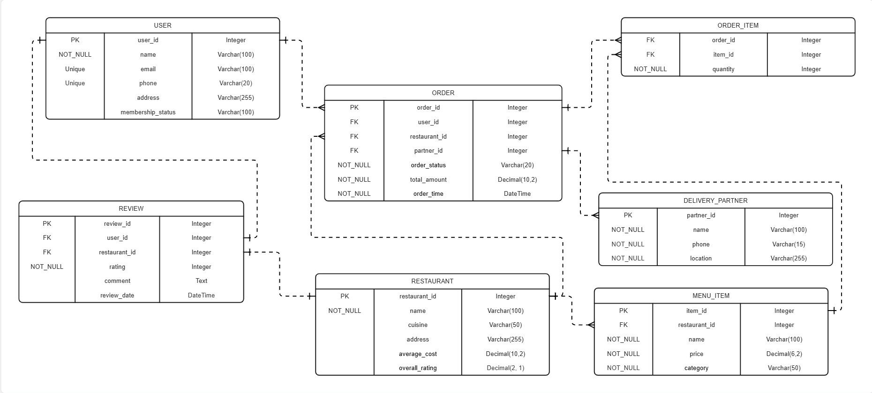

Conclusion:

Project Summary This product dissection highlights how Zomato acts as a perfect bridge between user needs and technical implementation.
- Functionally, the product solves real-world problems like "decision fatigue" and "logistics" through innovative features like Smart Discovery and Live Tracking.
- Technically, the Schema design demonstrates the complex relationships required to make these features work—connecting Users, Restaurants, and Delivery Partners through Orders.
Ultimately, Zomato’s success lies in its ability to manage these complex data relationships seamlessly in the background, providing a simple and delightful experience for the user on the front end.

